Providing Feedback and Formative Assessment during Distance Learning
Information for Parents/ Carers and Pupils

June 2020

General Guidance

At its most fundamental, teaching and learning involves three stages.

The first is instruction – when the child is provided with a form of input from which they can learn. This can include teacher instruction, reading, videos or the provision of activities and guidance for children to work things out for themselves.

The second stage is consolidation or exploration – when the child completes a task or an activity to help them to think about and further develop their knowledge and understanding of the instruction.

The third stage is assessment – this is when a ‘check’ of the learning takes place. This involves the teacher and child evaluating what has been learned and what needs to be done next. In truth, it is impossible to check a child’s learning on a short-term basis, but we can make a good guess by looking at their ‘performance’ through their work.
(St Joseph’s RC Primary School, Distance Learning Plan)

During the third stage – assessment – teachers will gather information about pupils’ performance after they have completed a task and use the data to inform future planning for learning. The method of feedback for tasks will vary and will be guided by the teacher’s professional judgement of the nature of the activity being undertaken and the needs of the learner. In some cases, it will not be possible or necessary to provide ‘formal’ feedback on the work that is set e.g. physical exercise or research. For others, feedback will be central in helping the learning and celebrate the effort and success of the learner.

The purpose of feedback within the context of distance learning:
- Maintain contact with learners
- Acknowledge and appreciate learners’ efforts, to celebrate their work and offer encouragement
- Support learners to ensure that they understand the tasks and respond to any misconceptions or misunderstanding that they may have
- Support the next steps of learning
- Help parents to support their children’s learning.

Feedback should:
- Be guided by the teacher’s professional judgement following their evaluation of the needs of learners and the activity
- Be communicated clearly and concisely
- Correct common misconceptions and misunderstandings.
(Central South Consortium, Distance Learning Considerations for Schools)

Using G Suite for Education

In order to achieve this at St Joseph’s RC Primary School, teachers will use the online G Suite for Education tools, accessible through hwb.

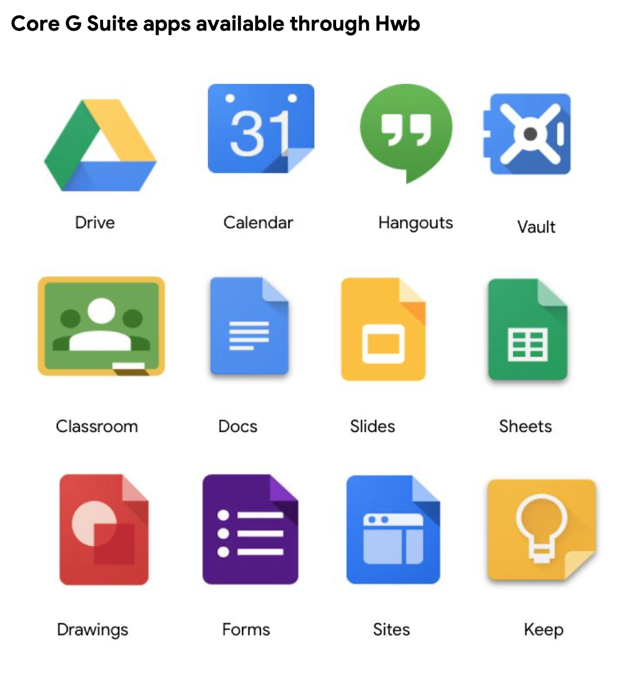
Navigating G Suite for Education for pupils

Each pupil will be assigned to a Google Classroom. Google Classroom is an online collaborative working environment for teachers and learners, with a wide variety of tools to explore.

When pupils log into hwb, they need to click on the icon ‘Google for Education’.

Here they will be able to click on their class and see a snapshot view of their assignments, teacher announcements, pupil questions, and other important class information. Pupils can submit their work directly through Google Classroom, and teachers can provide feedback and return the work. All of their work stays organised and conveniently stored on Google Drive.

Once they enter a classroom, pupils will find three tabs at the top of the page.
- The Stream tab (3 in the image below) shows a list of posts made to the classroom by the teachers and pupils. This includes announcements, questions and assignments.
- The Classwork tab (4 in the image below) stores all your child's assignments. Here, they'll see each assignment that's been added by their teacher. When they click on a task, they'll get the due date, details, resources needed, and status of the assignment. Pupils also can turn in their work here once it's completed. They can add files or create slideshows and images to be submitted.
- The People tab (5 in the image below) shows all the teachers and students in the classroom. It's also a place where students can communicate directly with one another or their teacher.
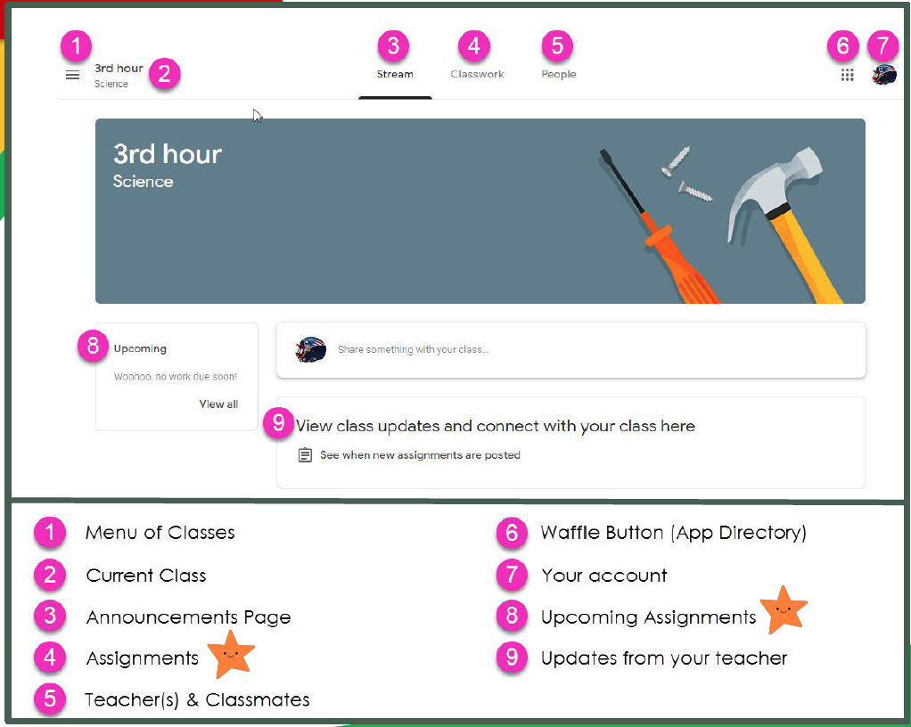

At a minimum, pupils will receive feedback:
- Daily: The answers to the previous mathematics/ English skills lesson (if appropriate) – these will be included within the uploaded work in the hwb classwork folder.
- Weekly: Within Google Classroom: One task assigned for formal feedback; one Google Form assigned for ‘assessing’ understanding of learning such as a ‘low-stakes’ quiz; an opportunity to ask questions/ converse with the teacher or class Learning Support Assistant ‘live’, through the use of Google Stream, at a specified date and time.
- Fortnightly: A general comment through email about pupils’ uploaded work, including praise for effort and progress.

Pupils are able to submit their assignment either using the template provided or by uploading an attachment e.g. a photograph of their work.

A video of how to upload an attachment can be found here:
https://www.youtube.com/watch?v=dpou7IbWWjI

Following a review at the end of this half term, of how successful the use of Google Classroom in this way has been, we will develop our use and frequency of the tools available, if appropriate, during the next academic year.

You can find out more about Google Classroom at https://support.google.com/edu/classroom/

