  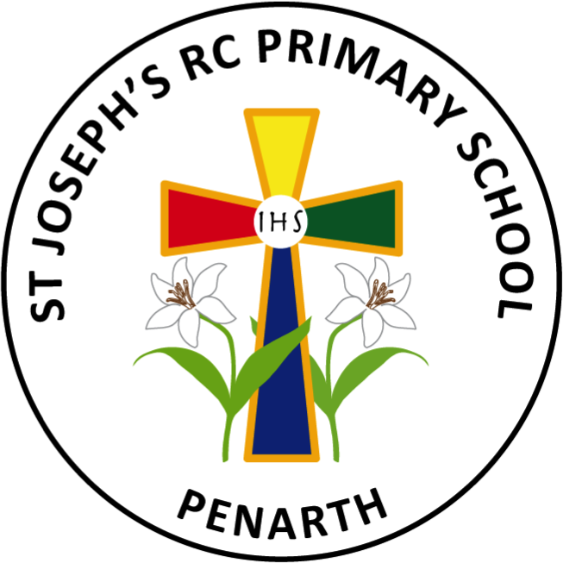  Cynefin: Developing our school: To develop and enhance the children’s experiences of encountering God and develop mission.  Chaplaincy Team 2025 - 2026     |   Community: Supporting our community: To continue to strengthen our link with St Helen’s, St Richard Gwyn (SRG), and with community projects like Hazelhurst and the Mini Vinnies.  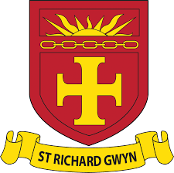  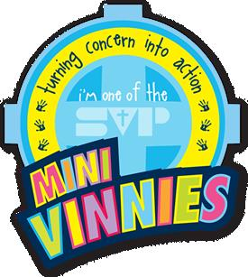  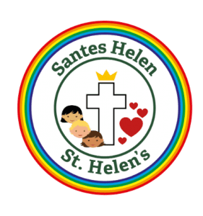
Citizenship: Helping to achieve the Global Goals: To work with Diversity Government Group on becoming a School of Sanctuary.



