Cynefin: Developing our school:  Criw Cymraeg 2025-2026  To develop a YouTube Channel of useful Welsh words and phrases using animation in Adobe Spark.  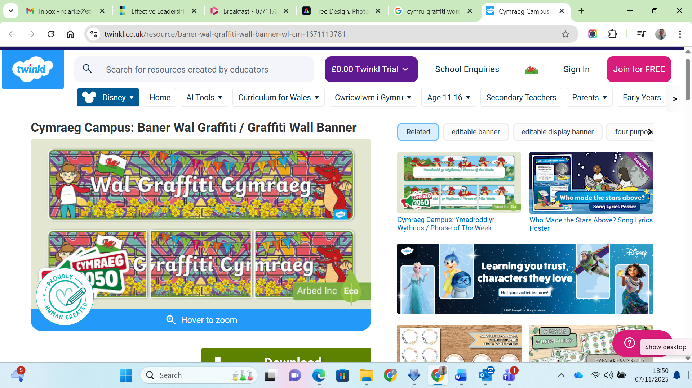  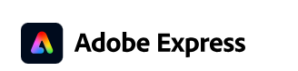  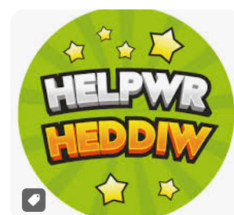 | Community: Supporting our community:  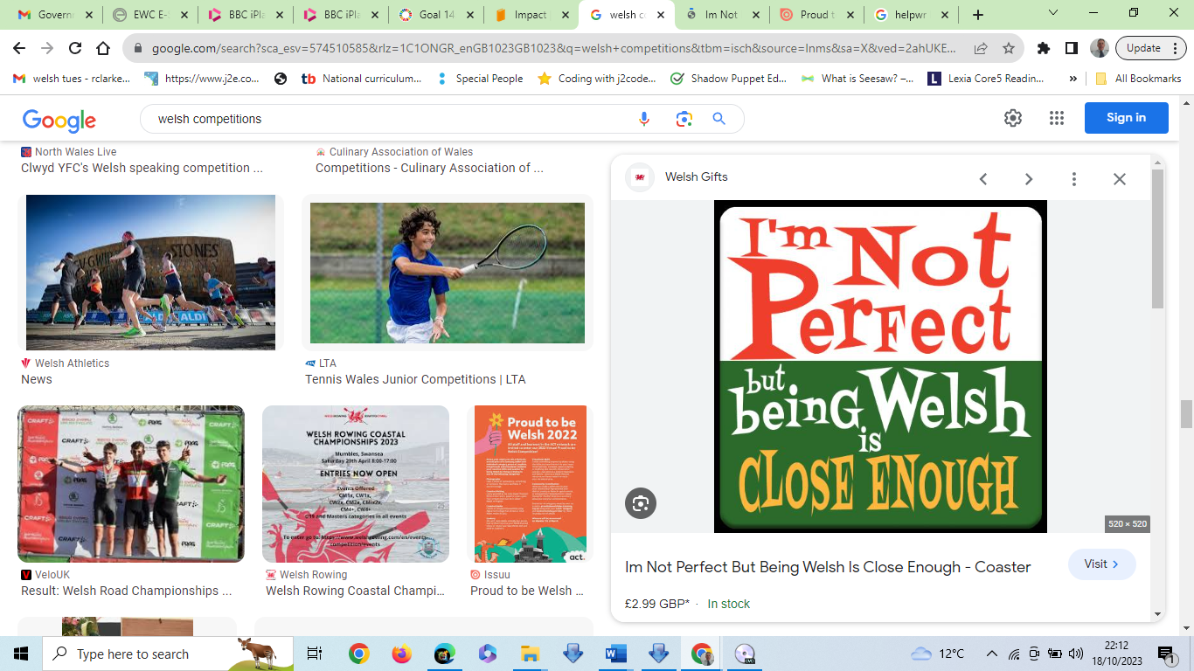  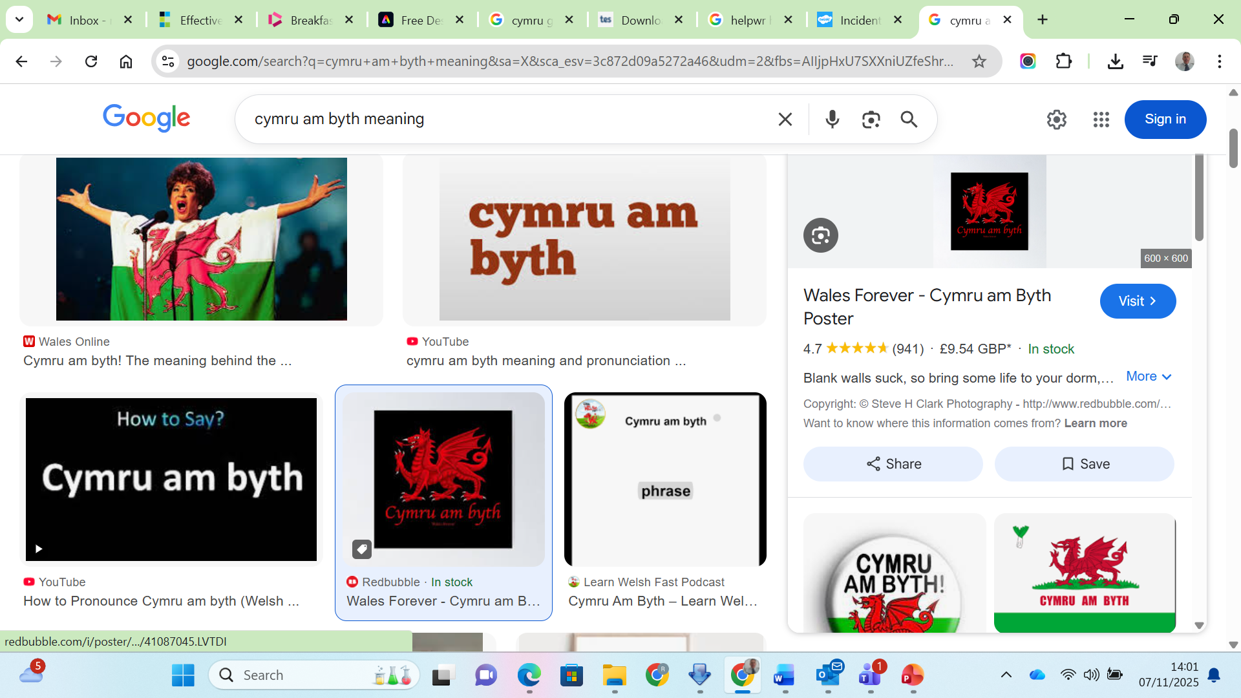  Hold a Welsh stall at The Christmas/ Easter/Summer Fayre.  Create an annual Welsh magazine to include information for parents on learning Welsh at home.
Citizenship: Helping to achieve the Global Goals:
Look at the Starter Iaith Silver award target cards and prioritised actions for development over the year.

Promoting language and culture, this group encourages a deeper understanding and respect for cultural heritage and identity, fostering harmony and peace. By, they contribute to mutual respect and understanding.


