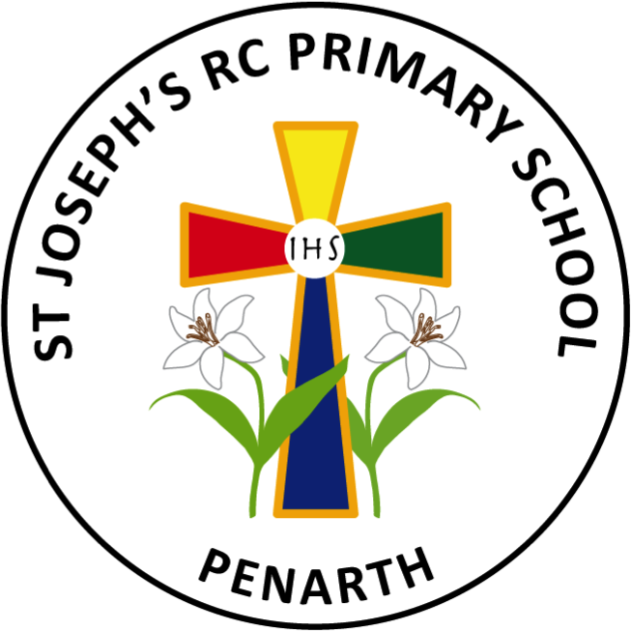
Curriculum 2025 - 2026

Cynefin: Developing our school:  - Organise a “BIG Literacy Festival” full day celebration.  - Lead an assembly to celebrate literacy and one to celebrate numeracy.  - Celebrate World Book Day in March 2026.   | Community: Supporting our local community:  Inviting parish members to celebrate with us on World Book Day – Read together.  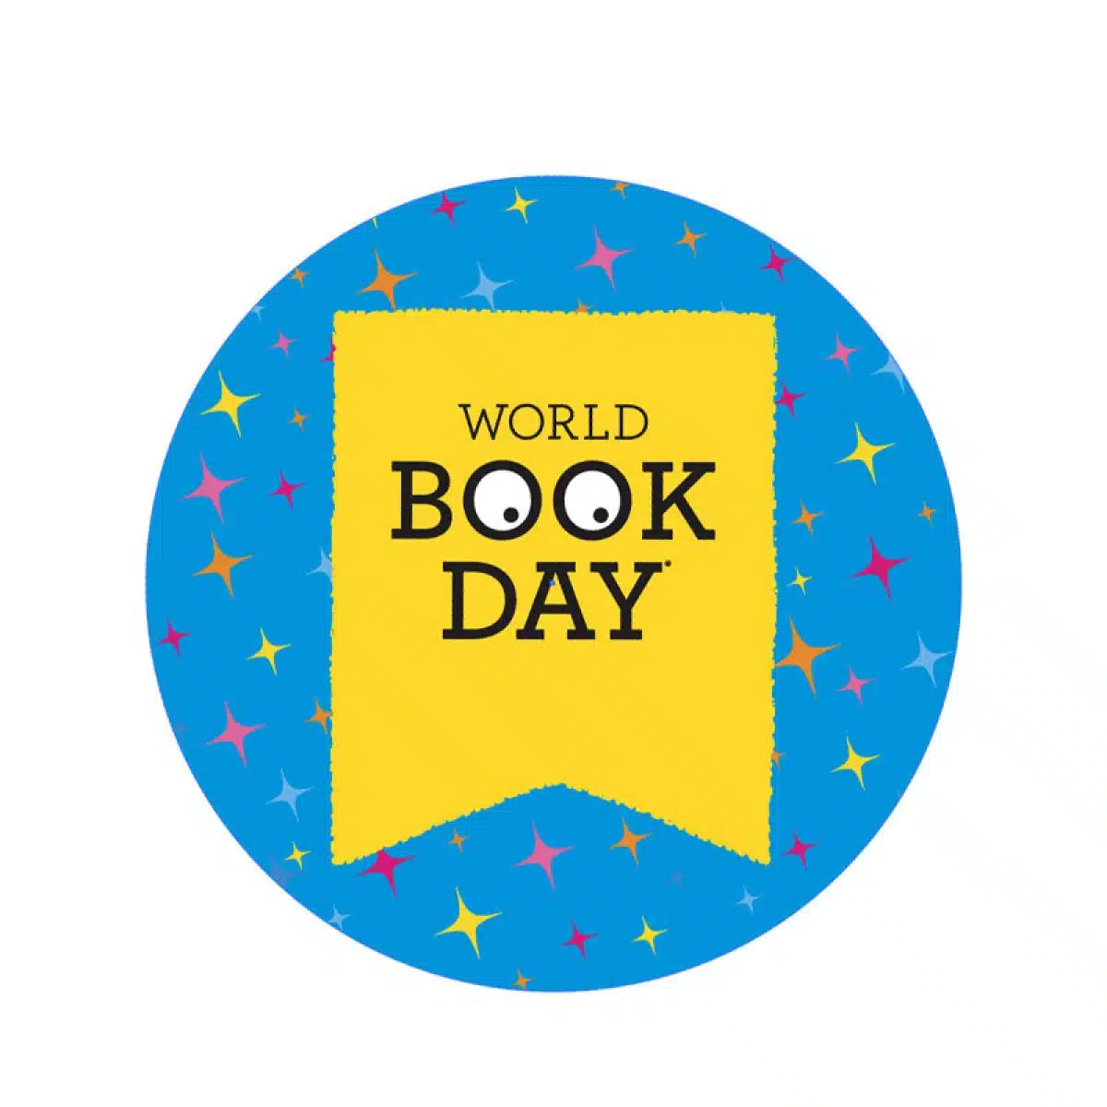
Citizenship: Helping to achieve the Global Goals:
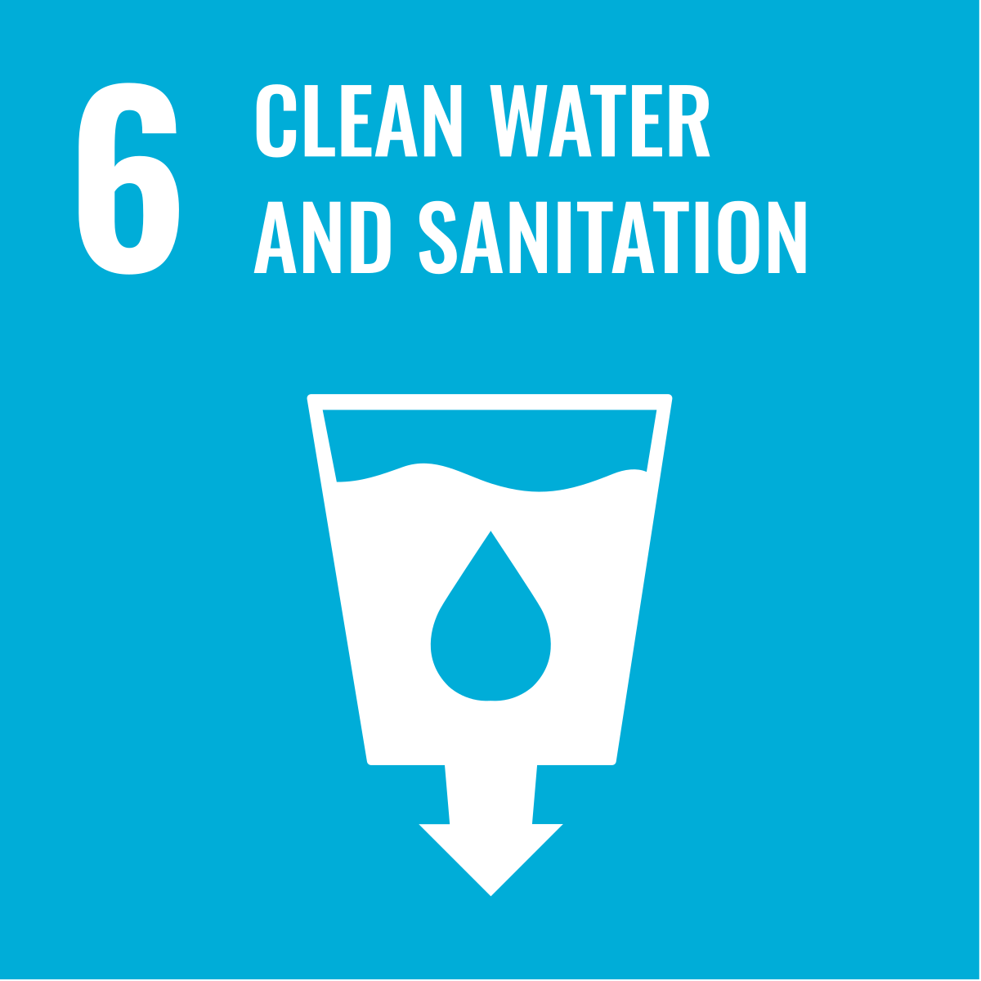
- Plan a learning week with one activity a day to help achieve the Global Goals.
- Fund-raising for a water charity or specific project.



