Diversity Group 2025 - 2026
Cynefin: Developing our school:  Promote inclusivity throughout our school through our anti-racist curriculum, young interpreter scheme and diversity assemblies.      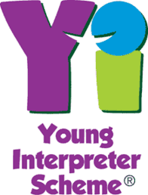 | Community: Supporting our local community:    Support Cardiff Refugee centres.      Create a welcome video and booklet to spread our diversity journey and welcome new pupils to St Joseph’s.
Cynefin: Developing our school:  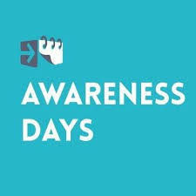    Diversify the curriculum through participating in Awareness days/ months, Refugee week and learning phrases from international languages that are represented within our school.    Develop our understanding of inclusion by looking at disabilities and learn sign  language. | Helping to achieve the Global Goals:  Work towards the School of Sanctuary Award.      

