
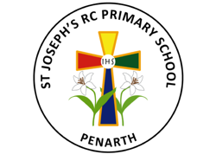
Eco Ministry 2025 - 2026
Cynefin: Developing our school:  Help our school care for God’s creation and protect the environment through litter picks, fortnightly electricity check in classroom and the correct use of recycling bins.  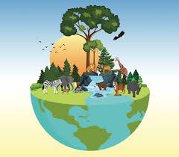 | Community: Developing our local community:  Take part in the RSPB Big Schools’ Birdwatch to help track and protect local bird species and create a bird friendly area in our outdoor area by adding feeders and bird baths.  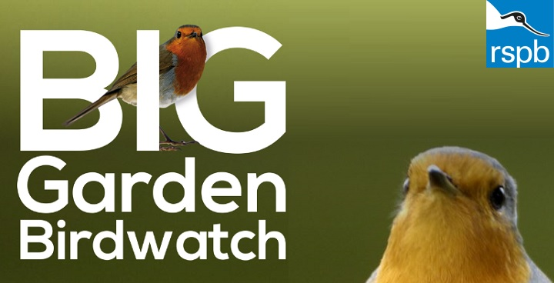
Citizenship: Helping to achieve the Global Goals:
Plan and deliver activities on Earth Day and World Oceans Day.




