

Health and Wellbeing Ministry 2025 - 2026

Cynefin: Developing our school:  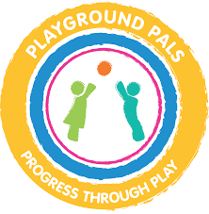  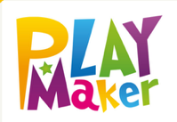  Health and Wellbeing Group Members will participate in Playground Pal training and Playmakers training at the start of the year. | Community: Supporting our community:  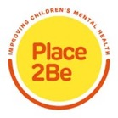  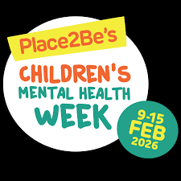  Promote and participate in Children’s Mental Health Week 9th – 15th February 2026
Community: Developing our school  Through the school year provide classes with wellbeing experiences, including Healthy and Confident Week. (Summer 2026)  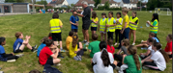 | Citizenship: Helping to achieve the Global Goals:  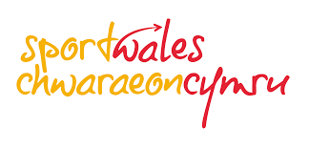  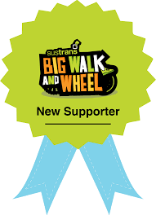  Participate in the Big Walk and Wheel Campaign (Spring 2026) and School Sport Survey (Summer 2026)

