Cyenfin: Developing our school:  To improve pupils’ IT skills through the use of Scratch/ AI Tournaments, Kahoot, Microbit and Minecraft Education.  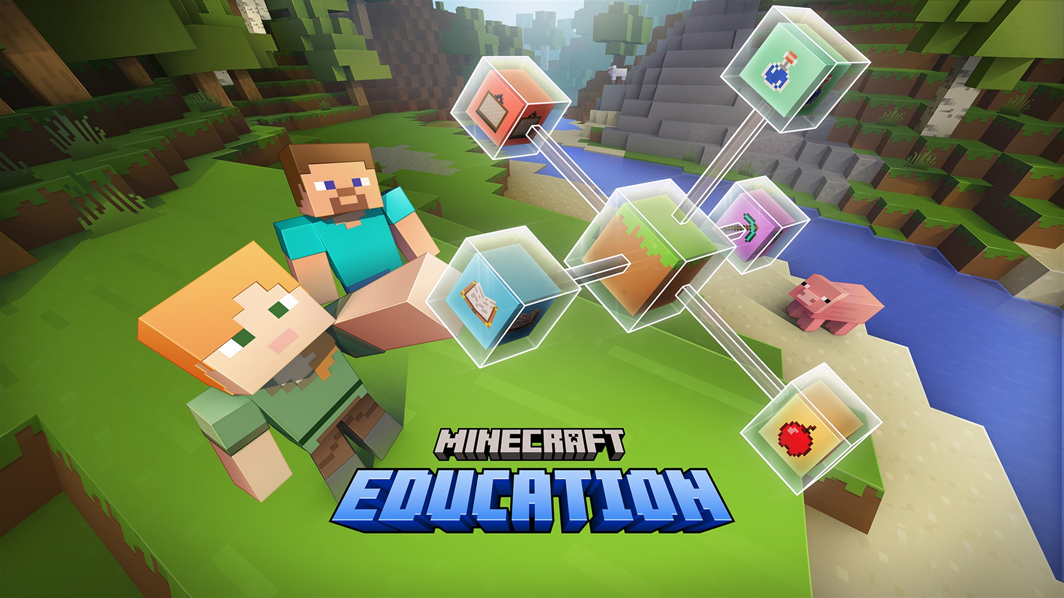   | Community: Supporting our community:  Develop the use of Instagram and the new school website.  
Citizenship: Helping to achieve the Global Goals:
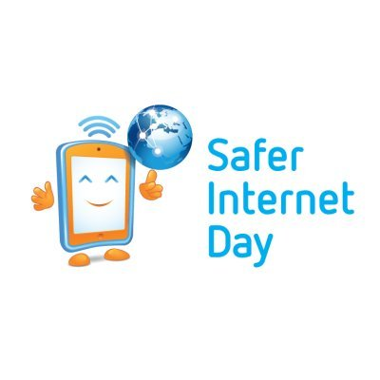
Become an Internet Safe School and lead activities for Internet Safety Day.
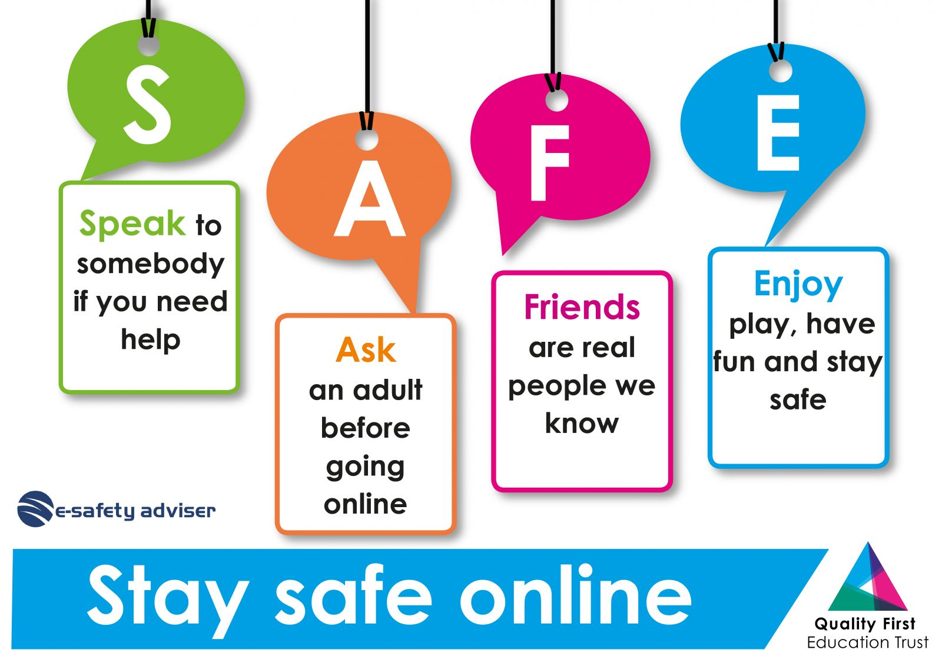
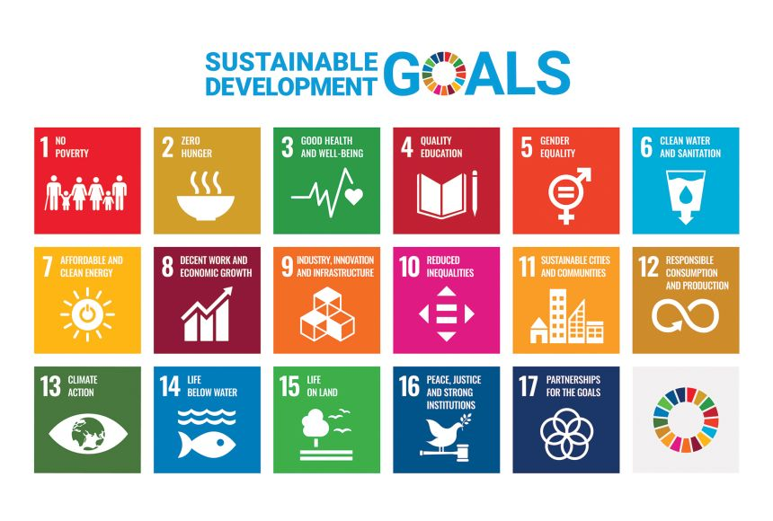


IT and Digital Safety 2025 - 2026

